ART-Chess：A Tangible Augmented Reality Chess on Tabletop

【Summary】：

We propose ART-Chess, a augmented reality chess on the desktop. With the desktop of a recognizable camera, the identification of markers is easier, which allows human players to use real pawns. Thanks to the AR headset, the game uses 3D virtual chess pieces, which makes the game richer. Players will use real chess pieces, while AI chess pieces will be created virtually and displayed in the headset system. To this end, we utilize existing desktops of perceptible cameras and AR headsets to come up with a simple gaming environment without the need for an external camera or projector.

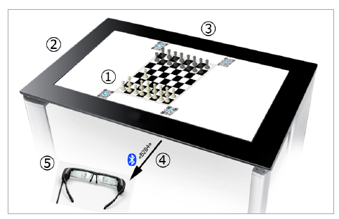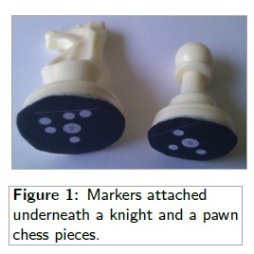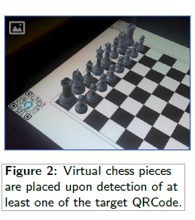

【Design】：

For the tabletop, a Samsung SUR40 has been used. The choice of this tabletop was motivated by the fact that it runs with Microsoft PixelSense [7]. Using a layer the PixelSense technology allows to detect various contact types such as ﬁngers, blobs and tags. Consequently, it is easy to detect and recognize chess pieces with markers attached underneath (see Figure 1). Each chess pieces have an unique marker that allow the tabletop to detect and recognize the exact position of the chess pieces on the surface.

Regarding the Android application, two platforms have been chosen. First, the Unity3D [10] has been used to create the virual reality. Chess piece, light, device camera and piece animation can easily be handled using Unity3D. Second the Qualcomm Vuforia [8] platform is leveraged for the AR functionalities. Vuforia is a ”vision-based augmented reality software platform”. It has an object recognition feature that allow to target, among others, images or user-deﬁned markers. The current prototype uses four QRCode as targets to place the virtual chess pieces on the chessboard (see Figure 2). VR headset such as Google Cardboard or Espon Moverio BT-200 can be used along with the Vuforia platform.

【Game steps】：

1. The player makes his move.

2. The tabletop detects the new position of the chess piece, and deduces the move. It checks the validity of the move to continue.

3. The AI [9] decides its own move.

4. A message with the selected move is sent to the Android device via Blutooth.

5. The Android device analyses the received message, and adapts the virtual scene consequently (piece movement or removal) .

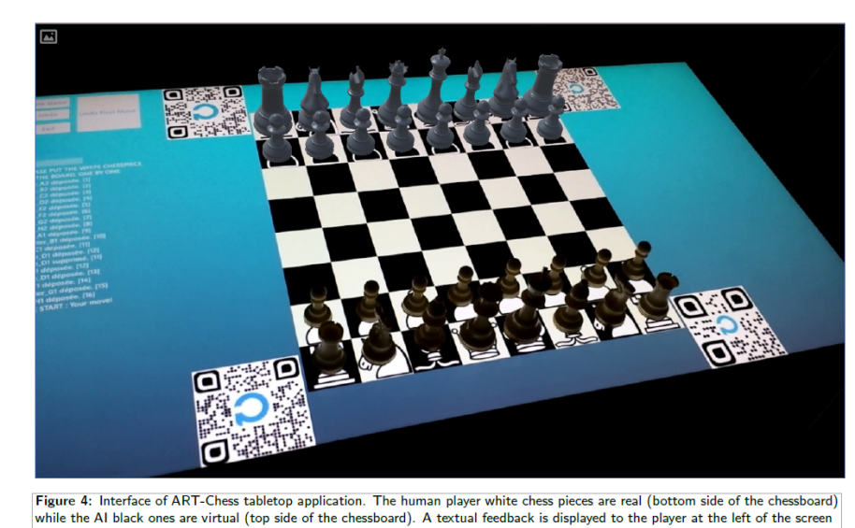

【Subjective analysis】：

The device is connected to the physical chess and chessboard through Bluetooth, android and other devices, and finally displayed to the player through AR. Increased touch with physical chess.